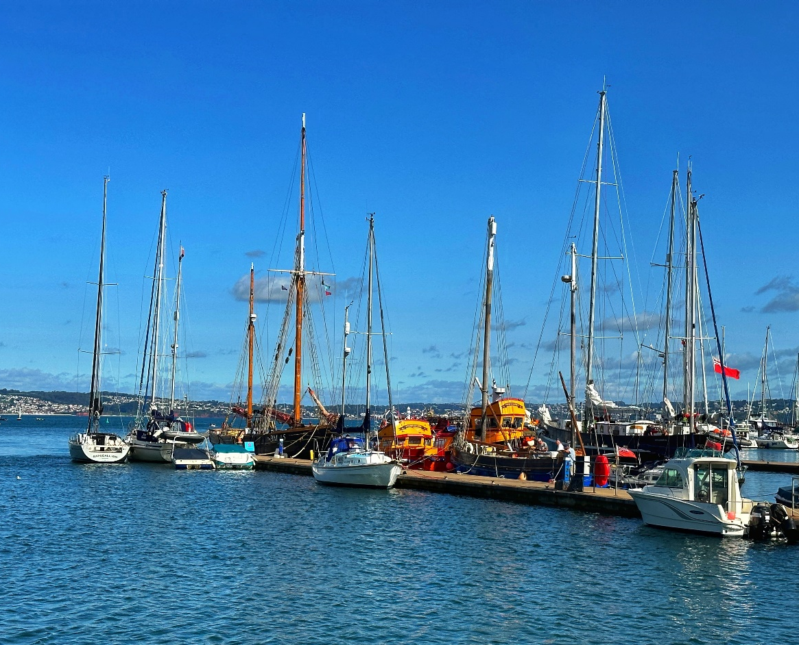


CHARGES, DUES & FEES
SUPPORTING INFORMATION
2026 – 2027

For the period 1st April 2026 – 31st March 2027

harbour.authority@torbay.gov.uk
www.tor-bay-harbour.co.uk
01803 208443

VAT Registration No. GB 142 2082 11

Contents

Section 1 – Introduction to Harbour Charges, Dues & Fees
- General Details Page 3–7

Section 2 – Visitor Facilities
- Recreational Visitor Charges Pages 8–10
- Passenger and Commercial Visitor Charges

Section 3 – Annual Harbour Facilities
- Recreational Annual Charges Pages 11–12
- Passenger and Commercial Annual Charges

Section 4 – Fishing Facilities
- Registered Fishing Vessel Visitor Charges Pages 13–14
- Registered Fishing Vessel Annual Charges

Section 5 – Services & Other Charges
- Services and Other Charges Pages 15–17

Section 6 – Pilotage Charges
- Pilotage Charges Page 18

Section 1

Introduction to Harbour Charges, Dues & Fees
General Details
    - The Tor Bay Harbour Authority ‘Charges, Dues and Fees – Supporting Information’ booklet should be read in conjunction with the ‘Schedule of Charges, Dues & Fees’ booklet, which can be found on the Tor Bay Harbour website:
www.tor-bay-harbour.co.uk/about/harbour-charges/

    - For more information regarding Tor Bay Harbour activities, please refer to the Tor Bay Harbour website: www.tor-bay-harbour.co.uk

    - Particular attention should be given to the following documents on the Plans & Polices webpage: www.tor-bay-harbour.co.uk/about/plans-policies/
    - ‘General Terms & Conditions’
    - ‘Operational Moorings and Facilities Policy’

    - All charges, dues and fees are subject to the appropriate rate of VAT except where indicated.

1.1.5 Annual charges relate to the period 1st April to 31st March following and any part thereof. Certain charges may be levied. The full annual fee will be charged for any person/s accepting a facility in the first 3 months (1st April – 30th June). Anyone accepting a facility after the 1st of July will be charged at the appropriate pro rata rate through to 31st March.

1.1.6 Seasonal charges, only where applicable, relate to the periods:
1st April to 30th September - Summer
1st October to 31st March - Winter

    - All accounts are to be paid within 14 days unless otherwise specified. Payment of charges listed may be required in advance of the service being taken up. Credit and debit card facilities are available for payments made online, at the Harbour Offices or via telephone.

    - Penalty for evading payment of charges – Section 30 Tor Bay Harbour Act, 1970:
“The owner of any vessel or goods or any other person who eludes or evades or attempts to elude or evade payment of, or refuses to pay, a charge payable by such owner or person to the harbour authority at the time when the same becomes due and payable shall be liable to pay to the harbour authority, in addition to the charge, a sum equal to the amount thereof, which sum shall be a debt due to the harbour authority and shall be recoverable by them in any court of competent jurisdiction.”

1.1.9 Failure to notify the harbour office of arrival, or departing the harbour without paying harbour charges, will be taken as an attempt to evade the payment of harbour charges.

1.1.10 Visiting vessels of special interest and/or vessels owned by Registered Charities may be eligible for a 50% concession on applicable Harbour Charges at the discretion of the Harbour Master.

1.1.11 Any person claiming the return of the whole or part of any charges paid to the Authority shall make such claim, produce all documents, and give all information required by the Authority in proof of such claim within twelve months from the time of payment and, in default thereof, the claim shall cease to be enforceable. Refunds would normally only apply in exceptional circumstances and will incur an administration charge.

    - All lengths referred to are overall lengths which in the context of these charges includes bowsprit, push-pit, stern davit, and/or bumpkin etc. as determined by the Harbour Master.

    - Any person who without reasonable cause fails to provide information which is reasonably required for the purpose of the harbour undertaking shall be liable on summary conviction to a fine not exceeding level three on the standard scale. (Section 18 Tor Bay Harbour (Torquay Marina &c.) Act 1983).

    - Application for and acceptance of a mooring, quay berth, boat park space, pontoon berth or other facility, implies acceptance of the rate of charge currently in force and of the conditions of issue including that the Authority and its staff are indemnified against any claims arising from or in connection with such berth or facility, save only as the Authority may be liable under the Unfair Contracts Terms Act 1977.

    - Vessels directed into the harbour by the Secretary of State’s Representative (SOSREP) or by any other person legally entitled to direct vessels into a harbour are required to pay one month’s harbour dues in advance as a condition of entry. If using a mooring facility, they will also be required to pay one month’s mooring fees in advance as a condition of entry. These charges are in addition to any charges incurred for pilotage, tugs, berthing the vessel or for the provision of any other service supplied by the Authority.

    - The lawful orders or directions of the Harbour Master and other authorised officers must always be obeyed promptly.

    - No facility granted may be shared, assigned, or sub-let without the prior consent of the Harbour Master in writing and further charges may apply (Tor Bay Harbour Byelaw no 38 & 41).

    - The Harbour Authority has the right to exercise a general lien upon any vessel, and/or her gear and equipment, whilst in or upon the Harbour premises, or afloat, until such time as the monies due to the Harbour Authority from the applicant in respect of such vessel whether on account of storage or mooring charges or otherwise, shall be paid.

    - No person shall place a vessel on a mooring prescribed in the mooring scheme prepared by the Harbour Authority for a vessel of a different size than that applied for, without the applicant obtaining the prior approval of the Harbour Master in writing (Tor Bay Harbour Byelaw no 40).

    - In the event of the applicant selling or otherwise disposing of the vessel authorised to use the mooring, the Harbour Master shall be notified in writing (Tor Bay Harbour Byelaw no 33).

    - These charges will be applied in a fair and equitable manner, to reflect, as reasonably as possible, the service provided. However, for the avoidance of doubt, the Harbour Master may interpret this Schedule in such a manner as to maximise income to the Harbour Authority.

    - The Harbour Master may vary these charges and/or levy additional charges in respect of anything done or provided by (or on behalf of) the Harbour Authority in accordance with the Harbours Act 1964 and/or Section 24 of the Tor Bay Harbour Act 1970 (or any amendments or re-enactments of those Acts) and all powers delegated to the Harbour Master.

    - The owner of any vessel using Tor Bay Harbour shall indemnify the Harbour Authority, their servants, and agents against all actions, claims, costs and demands in respect of any injury or death of any person and any damage to any property which may arise out of the owner’s occupation and use of the harbour facilities including slipways, steps, jetties, pontoons and staging and for this purpose shall maintain a Public Liability policy against such risks. Failure to maintain the appropriate insurance cover will result in the withdrawal of mooring, launching or other facilities.

1.1.24 Harbour Dues are payable on all vessels entering, within or leaving the harbour. Harbour Dues relate to a particular vessel and are not transferable. Refunds are not normally given.

1.1.25 Vessels, trailers and tenders paying Annual Harbour Dues must display their names as per Tor Bay Harbour Byelaw 34. Failure to do so may result in daily charges being applied.

1.1.26 Vessels exempt from Harbour Dues are as follows:
- Small vessels < 3m LOA propelled solely by oars or paddles and which are not normally berthed within the harbour.
- Canoes < 4m LOA, sailboards, and rowing skiffs
- Tenders less than 4.3m LOA for parent vessels paying relevant annual harbour charges that are less than 10.0m LOA.
- Tenders less than 6.0m LOA for parent vessels paying relevant annual harbour charges less than 10.0m LOA.
- Safety/rescue vessels as agreed with the Harbour Master
- All RNLI vessels
- HM Ships, Customs and Excise vessels and craft in the service of Trinity House

1.1.27 Tenders must be clearly marked ‘Tender to (the main vessel’s name). Only one tender per vessel is covered in this way. Tenders can only be used for transport to and from the parent vessel and/or mooring. All tenders shall be stored within designated tender racks except by prior written agreement from the Harbour Master.

Definitions
1.2.1 Limits of the Harbour
The limits of the Harbour shall comprise the areas as set out in Parts I and II of Schedule 1 of the Tor Bay Harbour Act, 1970.

    - Vessels
The word “vessel” includes every description of water craft, including non-displacement craft, WIG craft and seaplanes, used or capable of being used as a means of transportation on water. (International Regulations for Preventing Collisions at Sea 1972 – Rule 3)

    - Recreational Vessels
Any vessel, less than 50m LOA, used solely for the purpose of recreation. All vessels owned and operated by a registered charity for the purpose of training people at sea for recreational purposes.

    - Passenger Vessels
An MCA Class V, VI or VII vessel, or an MCA coded vessel, or, where applicable a vessel licensed by Tor Bay Harbour Authority to carry fare-paying passengers. Any vessel that meets this definition shall not be considered a recreational vessel.

1.2.5 Motor Fishing Vessels (MFV)
A registered Motor Fishing Vessel based in and working from a Tor Bay Harbour, the owner/master of which is engaged in commercial fishing, whose sole or main income is derived from selling fish on the Brixham Fish Market or landing fish for sale at Brixham, Torquay or Paignton Harbours and paying Fish Tolls to the Harbour Authority. Income from Fish Landings must total at least £12,000 in the previous year to meet the sole or main income test. Motor Fishing Vessel charges only apply to vessels bona fide engaged in fishing. Registered fishing vessels employed as pleasure craft and carrying passenger for reward are to pay the appropriate passenger vessel charge for the period so employed.

    - Commercial Vessels
Commercial vessels and all other vessels, including naval vessels, workboats and pilot boats used for any purposes other than recreation with the exception of, licensed passenger vessels, fishing vessels, or training vessels as defined in 1.2.2 to 1.2.4 above. See Operational Moorings & Facilities Policy for more information.

    - Heritage Vessel
A limited number of ‘Heritage’ vessels are permitted, with the Harbour Master’s consent, to berth on the Town Pontoon in Brixham Harbour. The Harbour Authority’s agreed criteria against which vessels could be measured for inclusion within the “fleet” of heritage boats based at Brixham Harbour is as follows:-
“that a heritage boat in Torbay be defined as a vessel which is British built, 40 feet or more in length and built prior to 31st December 1935 and that, at the absolute discretion of the Council, is considered to have an historical relevance to Tor Bay and its operation and general activity is considered to be beneficial to the local community; and that compliance with the approved definition of a heritage boat should form the basic criteria against which vessels can be measured for inclusion within the “fleet”.

    - Passenger
Any person carried that is not essential to the running of the vessel or any person who has paid to be transported, accommodated, or trained on the vessel on which they are embarked.

    - Work Within the Harbour
The loading, discharging, transport, carriage, storing or accommodation of goods, cargo, dry, liquid, or gaseous commodities, livestock, or passengers. The carrying out of any project for any purpose including but not limited to photographic, film or other artistic work on or by any vessel; capital dredging; diving support; pile driving or pile removal; laying or recovering an underwater cable or pipeline; laying, maintenance, survey or recovery of mooring anchors, ground tackle, risers or buoys; surveying, scientific research, water sampling or core sampling; and drilling into the river bed for any purpose. Any other project resulting in the construction or removal of any structure or the alteration of the harbour bed or infrastructure. Operations carried out by HM Customs, immigration officers, police and fisheries patrols but excluding firefighting and SAR operations.

    - Further Definitions
Definitions contained within the Harbours Act 1964, the Tor Bay Harbour Act 1970, the Tor Bay Harbour (Torquay Marina &c.) Act 1983 and Tor Bay Harbour Byelaws are applicable where appropriate.
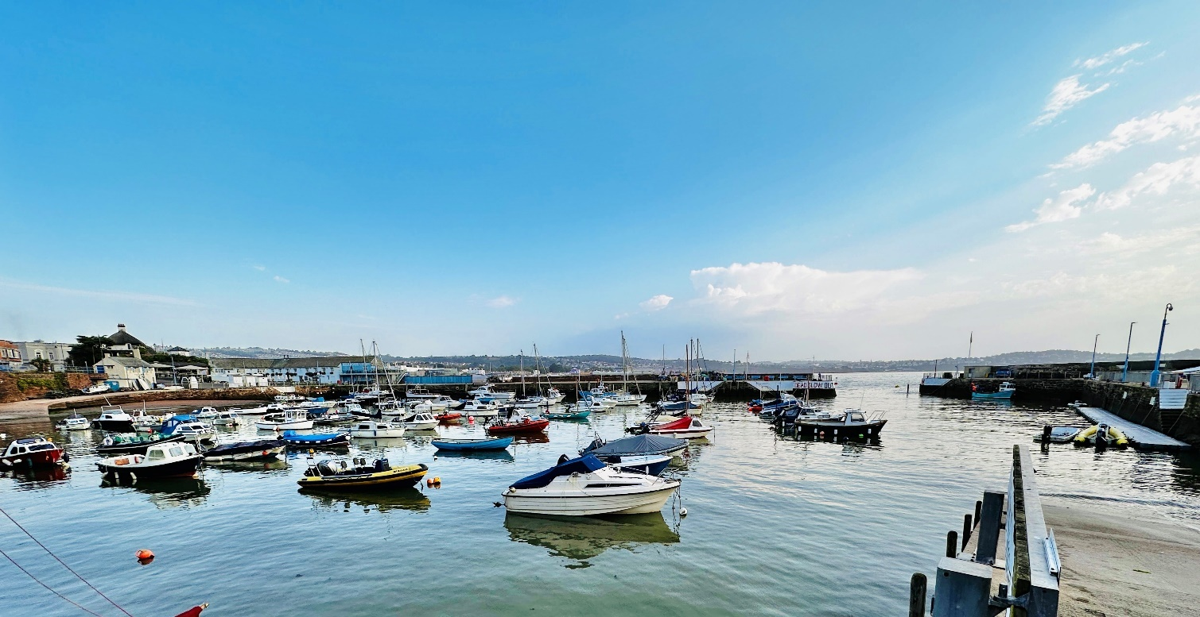

Section 2

Recreational Visitor Facilities

    - This section applies to both visiting recreational and passenger vessels. Recreational vessels refer to visiting non-commercial vessels under 50m LOA not undertaking work within the harbour; and visiting Passenger vessels (as defined in 1.2.3).

    - These charges apply at each of the enclosed harbours, and include both harbour dues and mooring fees where applicable.

2.1.3 Visitor Pontoons are available, normally for recreational vessels and visitor passenger vessels during the summer months in Brixham, Paignton and Torquay harbours.

2.1.4 Vessels may be required to double-up with other craft, and in such cases fendering will be the responsibility of the Masters of the craft involved. There is no reduction for doubling up.

    - To avoid the abuse of visitor moorings by local vessels, all craft using visitor mooring facilities will be charged as set out in the Schedule of Charges, Dues & Fees, and are normally restricted to a maximum stay of three weeks (21 days) with no return within one week 7 days. The weekly rate is only available for visiting vessels if payment is made in advance, the daily visitor rate will commence on the last day of the prepaid weekly rate.

    - Use of harbour facilities will be denied or withdrawn if boats are not adequately insured.

    - Harbour visitors are permitted up to 2 hours alongside free of charge before the charges set out in this section become due. Slipway charges are payable in addition to visitor charges.

    - Maritime events using pontoon or visitor moorings will be charged at 50% for the duration of the event and thereafter full price. All other charges are at the discretion of the Harbour Master.
Launch & Recovery Fees
2.2.1 Fees are charged per day. Vessels which frequently launch, or recover may, at the Harbour Master’s discretion, purchase an annual slipway pass subject to availability (see Schedule of Charges, Dues & Fees). Trailer parking charges (section 2.3.1) are in addition to these charges.

    - Launching kayaks from slipways in busy harbours is actively discouraged for safety reasons and is at the discretion of the Harbour Master, which may be withdrawn at any time. Safer alternative sites for this type of craft can be found on the Tor Bay Harbour website.

Personal Watercraft (Jet Skis)

2.3.1 All PWC must be registered with the Harbour Authority. Proof of insurance must be furnished upon request.

    - Use of launching/recovery facilities is at the Harbour Master’s discretion.

    - Launching/recovery charges do not include trailer parking.

    - To promote safety, persons holding a recognised RYA PWC will be charged the lesser ‘qualified’ rate. Proof of qualification will be required on each occasion.

    - Following implementation of the Merchant Shipping (Watercraft) Order 2023 on 31st March 2023, new laws apply to any type of powered watercraft, such as jet skis or motorboats. As a result, jet skis/PWCs are now subject to the same requirements as any vessel for adhering to the International Regulations for Preventing Collisions as Sea 1972 (COLREGs).

Trailer Parking
2.4.1 Trailer parking is subject to availability.

Quayside Berthing, Drying Out & Storage on Quays
2.5.1 Subject to availability

Use of Tor Bay Harbour Authority Landing/Embarkation Facilities for Passenger Vessels

2.6.1 Charges apply to passengers embarking/landing within any of the enclosed ports, at piers, pontoons, or any other fit-for-purpose harbour facility.

2.6.2 Passengers embarked as trainees aboard vessels owned and operated by a registered charity for the purpose of training people at sea for recreational purposes are exempt.


.Section 3

Annual Harbour Facilities

Berthing & Mooring

    - This section applies to vessels which are moored or berthed within Torquay, Paignton or Brixham harbours. Charges are levied per metre per annum or part thereof expiring 31st of March the following year and are inclusive of VAT, except where specified.

    - Annual berthing, mooring facilities and lying along quayside for passenger and commercial vessels are inclusive of harbour dues at £51.00 per metre per annum unless otherwise stated.

    - Vessels owned by charities or charitable organizations, including bona fide local youth organisations are eligible for up to 50% reduction of this charge at the discretion of the Harbour Master.

    - Waiting lists exist for some moorings & facilities. The registration fee to join each waiting list is £26.00 (£52.00 for commercial waiting lists). The fee is not refundable or transferable.

    - Permanent moorings and berthing facilities are allocated on an annual basis, 1st April to the 31st of March of the following year.

    - All other charges include VAT except where specified.

Parking, Quayside Storage Facilities

    - Annual charges for boat and trailer parking on quays are inclusive of VAT and include harbour dues. Charitable organisations, local yacht clubs, and recognised youth training organisations are invited (on an annual basis) to submit details of eligible young persons under 18 years old to be considered for the reduced rates.

    - All Boat & Trailer parking is subject to availability. Annual trailer parking is only available when an annual launching and recovery pass is purchased.

    - The annual trailer parking identified in this section does not entitle permanent parking of the trailer in the parking area. Customers seeking continuous trailer storage should refer to Boat & Trailer parking.

    - All personal watercraft (jet skis) must be registered with the Harbour Authority. Proof of insurance must be produced if so, requested by the Harbour Office or Harbour Patrol.

    - To promote safety within the Bay, persons holding a recognised RYA Personal Watercraft Certificate will be charged the lesser ‘qualified’ rate. Proof of such qualification will be required on each occasion.

    - Use of launching/recovery facilities is at the Harbour Master’s discretion.

    - Launching/recovery charges do not include trailer parking.

    - Charges for horizontal racks are inclusive of harbour dues.

    - Craft other than tenders to a larger vessel on a Tor Bay Harbour Mooring, will pay harbour dues in addition to the rack charge. Boat Park charges will be based on the greater length of either boat or trailer - if not stored on a launching trolley.

    - Beacon Quay reserved car parking spaces: allocation of spaces is subject to their being required by the Authority for up to 14 days per year to accommodate maritime events.

    - Winter storage is only available at Paignton Harbour for the period 1st October to 31st March following only (in whole or in part) and no reduction will be allowed for any lesser period.

Use of Tor Bay Harbour Authority Landing/Embarkation Facilities for Passenger Vessels

    - Charges apply to passengers embarking/landing within any of the enclosed ports, at piers, pontoons, or any other fit-for-purpose harbour facility.

    - Passengers embarked as trainees aboard vessels owned and operated by a registered charity for the purpose of training people at sea for recreational purposes are exempt.

    - Annual charges may instead be levied on passenger vessels which routinely land or embark within Tor Bay Harbour.

    - Passenger vessels other than MCA Coded and MCA class V, VI, VIA Passenger Vessels and EU Classes to be charged as commercial vessels.

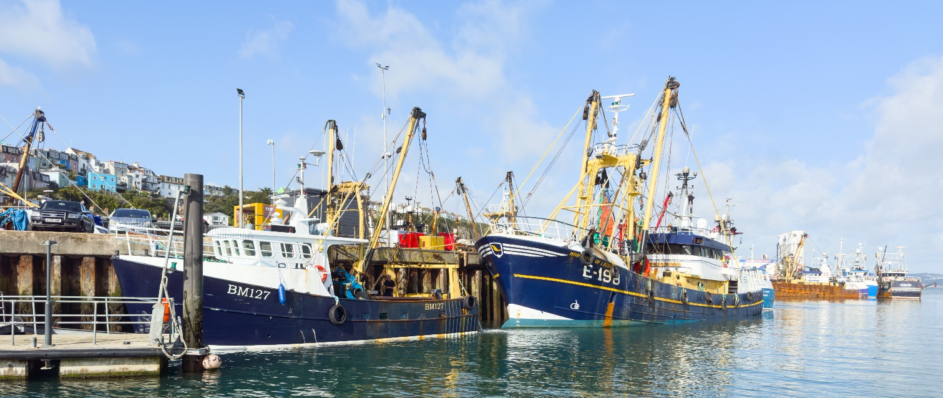
Section 4

Fishing & Commercial Vessel Facilities

    - Visiting Motor Fishing Vessels (defined in 1.2.5) has prices exclusive of VAT.

    - Where applicable, the charges in this section include mooring/quayside charges.

4.1.3 Vessels may be required to double-up with other craft, and in such cases fendering will be the responsibility of the Masters of the craft involved. There is no reduction for doubling up.

    - Use of harbour facilities will be denied or withdrawn if boats are not adequately insured.

Goods and Cargo Dues
4.2.1 Goods dues are levied on all vessels (VAT exempt for vessels of over 15 GRT) per occasion.

4.2.2 The payment of fish tolls includes alongside berthing within Tor Bay Harbour at a berth to be agreed by the Harbour Authority

Annual Registered Fishing Vessel Facilities - Harbour Dues
4.3.1 Applies to Motor Fishing Vessels (as defined in 1.2.5) normally moored within an enclosed harbour regardless of whether they are carrying out work or not). Prices are exclusive of VAT.

    - Charges are levied per metre per annum or part thereof expiring 31st March of the following year.

Berthing & Mooring
    - This section applies to vessels which are moored or berthed within Torquay, Paignton or Brixham harbours. Charges are levied per metre per annum or part thereof expiring 31st March the following year and are inclusive of VAT, however all vessels >15 GRT will be exempt and will have this removed at point of charging.

    - Waiting lists exist for some moorings & facilities. The registration fee to join each waiting list is £50.00. The fee is not refundable or transferable.

Goods and Cargo Dues
4.5.1 Goods dues are levied on all vessels (VAT exempt for vessels of over 15 GRT) per occasion.

4.5.2 The payment of fish tolls includes alongside berthing charge at Brixham and water consumption where a recharge facility does not exist.

Parking, Quayside Storage Facilities
    - Craft other than tenders to a larger vessel on a Tor Bay Harbour Mooring, will pay harbour dues in addition to the rack charge. Boat Park charges will be based on the greater length of either boat or trailer - if not stored on a launching trolley.

    - Beacon Quay reserved car parking spaces: allocation of spaces is subject to their being required by the Authority for up to 14 days per year to accommodate maritime events.

4.6.3 Winter storage is only available at Paignton Harbour for the period 1st October to 31st March following only (in whole or in part) and no reduction will be allowed for any lesser period.

Section 5

Services and Other Charges

Services and Other Charges
    - Electricity cards for electricity only, are available in the following denominations for the respective price (prices listed are inclusive of 5% REDUCED RATE VAT):

- Level 1 card – 10 Units (Unit charge varies in accordance with current rates)
- Level 5 card – 50 Units (Unit charge varies in accordance with current rates)
- Level 10 card – 100 Units (Unit charge varies in accordance with current rates)

    - These utility charges are applicable only where a recharging facility exists, e.g., card/token meters or sub meters. Also, these charges are linked to the relevant energy prices at any given time, so the price per unit varies in accordance with the current rate by the supplier.

5.1.3 Water taken in quantities of less than one tonne there is no charge except where a recharge facility exists.

    - For water supplied from the Tor Bay Harbour’s standpipes the following charges apply:
- Up to 50 Tonnes – per tonne
- 50 tonnes and over – per tonne
    - Other charges below apply where water recharging facilities are not available through metered services.

Crane, Labour, and Equipment Hire Charges
5.2.1 Use of mobile commercial cranes or other lifting appliances (including Hiab’s) on Harbour estate is at the Harbour Master’s discretion. At least 48 hours advance notification must be provided for each operation, together with all relevant documentation (RAMS, Lift Plans and Permit to Work).

5.2.2 Enhanced rates will be charged, out of ordinary working hours, where overtime is required to be worked. If staff have are called out, a minimum of 2 hours overtime will be charged (per person).

5.2.3 Tor Bay Harbour Authority personnel and equipment (subject to availability) are charged out at the following rates all including VAT. Hire of these facilities are at the Harbour Masters discretion.

    - Towing and water taxi services are provided at the discretion of the Harbour Master.

    - Use of forklifts on harbour property/estate is at the discretion of the Harbour Master.

    - Forklift truck services to Ship’s Agents, includes labour up to 30 minutes and minimal storage up to 1 week.

Storage Space
    - No unauthorised storage is permitted, and items may and will be removed and disposed of without warning.

    - For authorised stores, a charge will be made.

    - Secure storage may be available upon request and with authority of the Harbour Master.

    - Moving equipment into storage will be charged at the applicable rates in 4.2.

Licences (Exclusive of VAT)
5.4.1 Fish salesmen’s and buyer’s licences are valid from 1st April each year.

5.4.2 The period of validity for a Boatman’s licence must run concurrent with their DFT licence - MCA and Code of Practice Boatmen only.

    - Tor Bay Harbour Authority may grant upon such terms and conditions as they may think fit licences for pleasure craft to be let for hire or to be used for carrying passengers for hire within the Harbour, and to the boatmen or persons assisting in the charge or navigation of such craft. (See section 22 (1) Tor Bay Harbour Act 1970).

Bunkering Charges (Exclusive of VAT)
5.5.1 Bunkering charges do not apply where fuel is taken from the refuelling stations at BTA fuelling station at Brixham, Brixham Marina or South Pier at Torquay.

Waste Charges
5.6.1 Waste/rubbish that litters the Harbour Estate as a result of refit or repair work may be removed by the Harbour Authority. Fishing vessels undergoing a refit will be required to provide a sealable skip for produced waste and are responsible for the management of the skip during this time. Sufficient spill and absorbents are to be available to contain any pollutants due to their activities. Torbay Harbour will not dispose of Cylinders. Charges may be applied for disposing of waste and clean-up operations.

5.6.2 A significant contribution towards the reasonable cost of Port Waste reception facilities for vessels covered by the Port Waste Reception Facilities Regulations 2003 will be made by way of a consolidated harbour dues charge where applicable. With the exception of small volumes of waste oil, the charge for receipt of dirty ballast water, tank washings (slops), oily mixtures containing chemicals, scale and sludge from tank cleaning operations, oily bilge water, sludge from purification of fuel oil, noxious liquid substances, sewage, and excessive volumes of rubbish will be levied at cost plus 10%.

Miscellaneous Charges (inclusive of VAT unless stated)

5.7.1 The parking of exhibition vehicles on Harbour Estate is at the discretion of the Harbour Master.

5.7.2 Pleasure Boat Advertising Boards are licensed sites and are subject to a tendering process.

    - Vessels of exceptional construction or methods of propulsion, or not otherwise covered which include sea planes, hovercraft, hydroplanes, hydrofoils and similar craft, rafts used for recreational purposes, etc. See Operational Moorings & Facilities Policy Definitions, Item 7

    - Annual Contractors passes are valid from 1st April each year and are subject to Terms and Conditions of Use.

    - The Tor Bay Harbour Authority may from time to time apply a charge for officers’ time for work undertaken by officers preparing reports or supervising work that is not the Harbour Authority’s responsibility.


Section 6
Pilotage Charges

Services of a Pilot and/or Pilot Boat (Exclusive of VAT)

    - Extract from Tor Bay Harbour Pilotage Directions

Pilotage shall be compulsory within the compulsory pilotage area for all vessels except:-

- any ship of Her Majesty’s Royal Navy or Royal Fleet Auxiliary;
- foreign warships navigating in the harbour for the purpose of taking up or leaving an anchorage;
- any vessel of less than 36m LOA entering or leaving an enclosed harbour and not carrying a cargo of dangerous goods or marine pollutants;
- any vessel of less than 80m LOA providing they do not enter or leave an enclosed harbour
- any vessel engaged in towing where the length of such vessel aggregated with the length of the tow is less than 80m or less than 36m for those entering or leaving an enclosed harbour;
- any fishing vessel less than 47.5m LOA;
- any vessel, or vessel engaged in towing, proceeding to, or departing from a designated anchorage provided such vessel has been forced by stress of weather to seek shelter.

See www.tor-bay-harbour.co.uk for the latest version of the Tor Bay Harbour Pilotage Directions

Note – Add 50% surcharge to Pilotage Charges incurred on Bank Holidays

Charges for Pilotage Exemption Certificates
6.2.1 Pilotage Exemption Certificate, per issue



