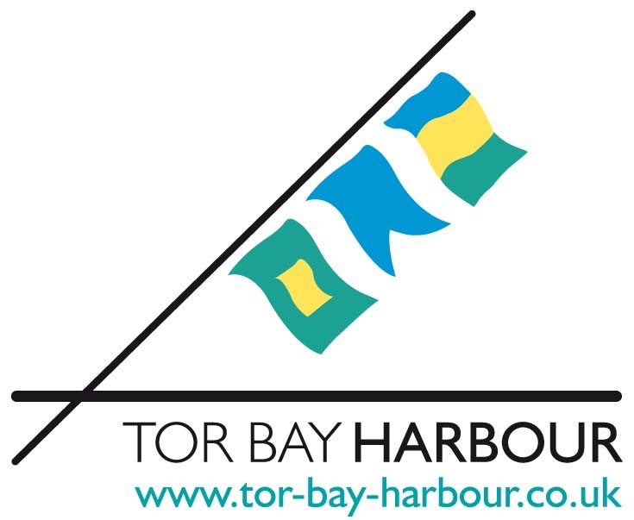

GENERAL CONDITIONS OF USE FOR EVENTS IN TOR BAY HARBOUR, HARBOUR ESTATES, BEACHES & PROMENADES.

The event organiser shall:-

1. Provide the relevant Harbour Master or Deputy Harbour Master with the following information, where applicable, at least two months prior to the event:
- Schedule of race times and practise sessions
- Course plan, or areas where courses will be laid
- Contact details for Race and Safe Officers, and Call signs
- VHF Channels being used by safety boats and race officials
- Number of vessels taking part
- Shore side facilities required
- Event Risk Assessment
- Proof of event & public liability insurance
- Event management and safety plan
- Any other documentation requested by The Harbour Authority

2. Ensure all vessel masters are briefed on safe procedures for entering and exiting the enclosed harbours.

3. Keep Tor Bay Harbour Authority informed of all relevant information during your event on VHF channel 14.

4. Indemnify the Harbour Authority, its servants and agents against all actions, claims, proceedings, costs and expenses howsoever arising out of or in connection with the organisers occupation or use of the Harbour, unless caused by the negligence of the Harbour Authority, and the organiser shall effect or have in place a policy of insurance covering all the matters which are the subject of the indemnities and undertakings herein. The minimum level of insurance cover shall be £3M in respect of any claim or series of claims arising out of one event but it remains the responsibility of the organiser having taken independent professional advice to determine the appropriate level of cover having regard to the nature of their operation and the perceived level of risk.

5. Not use the site for any purpose other than that for which the agreement shall be granted.

6. Not assign or transfer the benefit of the agreement.

7. Follow all directions/instructions from the Harbour Master and or their delegate.

8. Inform the Harbour Master each day of that days intended vessel movements within the Harbour and use of mooring facilities.

9. Allow the Officers of the Harbour Authority at all times to have full right of access to any facility placed on the estate for the purpose of inspecting or examining the same and the applicant shall at all times comply with their instructions or requirements. The Council does have an event guide, which is designed to help organisers plan and safely run their event. For a copy of the Purple Guide (the HSE event safety guide) go to http://www.hse.gov.uk/pubns/books/hsg154.htm

10. Not carry on or allow or permit to be carried on unlawful betting and gaming.

11. Not play or permit to be played music of any description or use or permit the use of loudspeakers, amplifiers, whistles, bells or other noisy instruments without the prior written agreement of the Harbour Authority and in no case later than 10.00pm. A Premises Licence for (Entertainment only) may be held on the land required for your event. Contact the Harbour Authority for the full list of sites and Conditions. If not and your event is public and consists of music, dancing, singing or similar, contact the Safety & Licensing Section of Torbay Council regarding a Temporary Event Notice.

12. Not light or cause or permit to be lit any fire without the prior written agreement of the Harbour Authority.

13. Comply with the requirements of the Harbour Authority or the Officer of the Fire Authority as to the provision of proper means for the extinguishing of fire and to complete a Fire Risk Assessment.

14. Not permit painting, advertisement or other notices or signs whatsoever to be exhibited on the site except with the previous written agreement of the Harbour Authority and the organiser shall be responsible for advertising activities in connection with the event and in particular shall be deemed to have full control of any advertising agents employed or otherwise used. If any person carries out fly-posting in connection with the event, then this Agreement shall be immediately cancelled and any deposit paid shall be forfeited to the Council and may be used by the Harbour Authority to offset the cost of removing unauthorised advertising material.

15. Not exhibit or give as prizes any fish, birds or live animals. No livestock to be used for the purpose of riding or amusement by the public. Unless in agreed circumstances with the prior written consent of the Harbour Authority.

16. Not encroach on any other land of the Council or any highway but shall conduct the activity for which the permission shall be granted and keep all equipment and other things of whatsoever kind used for or in connection therewith within the site.

17. Apply to the Harbour Authority for any on-site parking requirements during the event. All other vehicles are restricted to loading and unloading.

18. All applications for use of Harbour Estates, beaches or promenades should be accompanied by a site plan showing the approximate layout of the event, including: - (not less than 6 weeks before the date of the event)
i) A Medical Plan to cover all those attending the event;
ii) The number of tents/kiosks/marquees;
iii) A litter/waste plan to cover the whole area of the event;
iv) The approximate size and location of any structure;
v) The total area to be taken up by the event;
vi) Notification to the Council of marquee erection and dismantling dates (not less than 6 weeks prior to the event);

19. Keep and maintain the site in a clean and tidy condition (providing litter bins, skips where necessary) and take all necessary steps to prevent any inconvenience or annoyance to the Harbour Authority or boat owners, or general Harbour users or to members of the public. The organiser shall be responsible for the clearing and removal of all litter. On the expiration of the period of occupation the organiser to deliver up the site to the Harbour Authority in a clean, tidy and orderly condition. If this has not been completed to the satisfaction of the Harbour Master it shall be lawful for the Harbour Authority to do such works as deemed necessary and recover the cost thereof from the event organiser.

20. Ensure that all relevant consents and licences incidental to the use of the Harbour are obtained and that there is full compliance with all relevant statutory provisions including those relating to entertainment licence, PRS Licence, public health, food hygiene, planning and health and safety at work.

21. Not make any charge to the public in respect of admission to the site without the express written permission of the Harbour Authority.

22. Note that licensed bars or sales of alcohol are not permitted at events on any Council owned land, unless in agreed circumstances with the prior written permission of the Council.

23. a) Provide any equipment required for their activity. All equipment shall be suitable
for its purpose and in such a condition as not to cause nuisance, annoyance, injury or damage to any person or property and shall be removed as soon as the activity is concluded. All such equipment shall comply with all Health and Safety requirements and be covered by a current public liability insurance against defect and use.
b) Be responsible for personally verifying the legality of every stall and attraction that is to attend and for ensuring that they have adequate public liability insurance, and that their charity registration numbers are displayed on the day of hire.
c) Hold evidence of such compliance on site during the event.

24. Be responsible for any sub-contractor, caterer or employee. The organiser shall accept full responsibility for and will fully indemnify the Harbour Authority against all costs, charges, claims or actions for or in respect of any injury to any person, unless caused by negligence of the Harbour Authority, or any loss or damage to property or to the land, buildings or fittings let to the hirer. All articles brought on to the Harbour or other Council property, are at owner’s risk and the Harbour Authority will not be responsible for any loss or damage to clothing or other property of any person or persons.

The organiser shall also note the following conditions:-

- CANCELLATION. The Harbour Authority may at any time cancel its permission to use the site of any part thereof in circumstances which the Harbour Authority deem appropriate including but not limited to, either the protection of the site or supervening need for the Harbour to be used for another (e.g. Civic) purpose. The Harbour Authority will not be liable to make or pay any compensation for such cancellation.

- The organiser to comply with all Tor Bay Harbour byelaws.

- If any part of your event has an impact on other land and other sections of Tor Bay Council, such as Highways, toilets, waste/litter, the appropriate section must be contacted to gain approval before the event is confirmed by the Council.

NOTE

In these Conditions the “Harbour Authority” is a section of the Council of Torbay and includes any Officer nominated to carry out such duties on behalf of the Council.

